World Skin Health Day 2022 - Suggested newsletter text and images

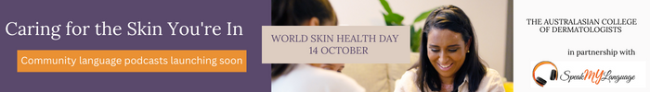

The Australasian College of Dermatologists (ACD) is celebrating its 5th World Skin Health Day on Friday, 14 October 2022 with the launch of a set of community language podcasts and social media campaign, Caring for the Skin You’re In, to encourage Australians from culturally and linguistically diverse backgrounds to seek help for chronic skin, hair and nail conditions.
The podcasts aim to improve access to information and feature interviews with dermatologists from culturally and linguistically diverse backgrounds. Recorded in Cantonese, Korean, Spanish, Hindi, Arabic, Turkish, Persian and in English, the dermatologists discuss the impact of skin, hair and nail conditions, and how to access reliable information, help and support.
The podcasts were developed as part of a podcast project Speak My Language (Disability). The Speak My Language (Disability) program is funded by the Commonwealth Department of Social Services and is proudly delivered by the Ethnic Communities’ Council of NSW as the lead agency in partnership with all State and Territory Ethnic and Multicultural Communities' Councils across Australia.

Visit ACD’s World Skin Health Day 2022 webpage to find out more.
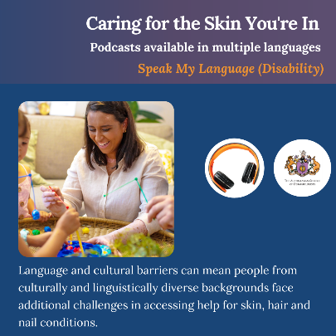
Download Image

